

# American International University-Bangladesh (AIUB)

# Department of Computer Science

# Faculty of Science & Technology (FST)

Spring 22-23

Section: B

Software Quality Assurance and Testing

**Project Title:** Smart Learner

Submitted by -

|  |  |
| --- | --- |
| **Student Name** | **Student ID** |
| Rafi, Kafi Anan | 19-39882-1 |
| Shawon, Mohammed Ibrahim | 19-40767-2 |
| Ameen, Tasneem Binte | 19-41533-3 |

Under the supervision of

**ABHIJIT BHOWMIK**

**SOFTWARE TEST PLAN**

Designed for -

**SMART LEARNER**

Version 1.0

Date: 3-May -2023

American International University-Bangladesh (AIUB)

Table of Contents

1. TEST PLAN IDENTIFIER 4

2. INTRODUCTION 4

Background to the Problem 4

Solution to the Problem 4

3. SYSTEM SPECIFICATION 4

a. System Features 4

4. System Interface 7

5. FEATURES NOT TO BE TESTED 12

6. TESTING APPROACH 13

6.1 Testing Levels 13

6.2 Test Tools 13

6.3 Meetings 13

7. TEST CASES/TEST ITEMS 14

8. ITEM PASS/FAIL CRITERIA 20

9. STAFFING AND TRAINING NEEDS 20

10. TESTING SCHEDULE 21

11. PLANNING RISKS AND CONTINGENCIES 21

12. APROVALS 21

## TEST PLAN IDENTIFIER

TP_SmartLearner_1.0

## INTRODUCTION

### **Background to the Problem**

Technology has changed everything around us. It has a great impact on how we do things and how we learn. Though online education has increased for the past few years, it still has some major problems. Online education is unattractive and boring. Even if student have learned something, but retaining the learning is another issue what students struggle with. So, it needs to be changed.

### **Solution to the Problem**

Smart Learner is a learning platform which focuses on two major aspect of learning which is missing in online education. One is learning based on scientific techniques that focuses on enjoyable and engaging learning experience. Another is retaining that learning content using various scientific tools like summarization, flash quiz, Feynman technique etc. This platform is dedicated for these two aspects which can give the education a new meaning and help students massively in their learning curve.

## SYSTEM SPECIFICATION

### System Features

#### Signup

* 1. The user will sign up with unique username, email, phone, password and other information.
  2. The system will verify the user through provided email or phone number.

Priority Level: Medium

Precondition: User have valid email/phone.

#### Sign in

* 1. Sign in with user username and password.
  2. If the username/password are entered incorrectly more than four times, the system will send user a random authentication code in given phone number to retry log in.
  3. If the username and password match the database details, the user will be able to visit the homepage based on their user type.

#### Updating Personal Information

* 1. The user will be updating their personal information in the profile section.
  2. If the user adds an email address or a phone number later, the system can validate it.
  3. The system will ask the user to enter password if the user chooses to delete existing email/phone.

Priority Level: Medium

Precondition: User has to logged in to the system, valid password, access to email/phone.

#### Student Learn section

* 1. The student will choose the subject
  2. The student will be able to see the content of the subject
  3. Resources should be protected.

Priority Level: High

Precondition: User has logged in to the system

#### Student retention center

* 1. Student should be able to save the summaries and create them.
  2. They should be able to see all the summaries created.
  3. There should be a section to browse only their own summaries.
  4. There should be a quiz section for giving quiz on different subject.

#### Request gallery

#### Request gallery should hold all the topics requested by students.

#### There should not be more than four request in a session.

* 1. Requests should be discarded once they are accepted by any student.
  2. An automated mail should be generated to notify the parties involved.

#### Creator

#### Creator should be able to create content.

#### Request gallery should hold all the topics requested by students.

#### There should be a separate section for creators to see their own content.

#### Resources should be protected.

## System Interface

System interface where the users will interact with the system’s functionality are given below with

Description

* + 1. **Landing Page**

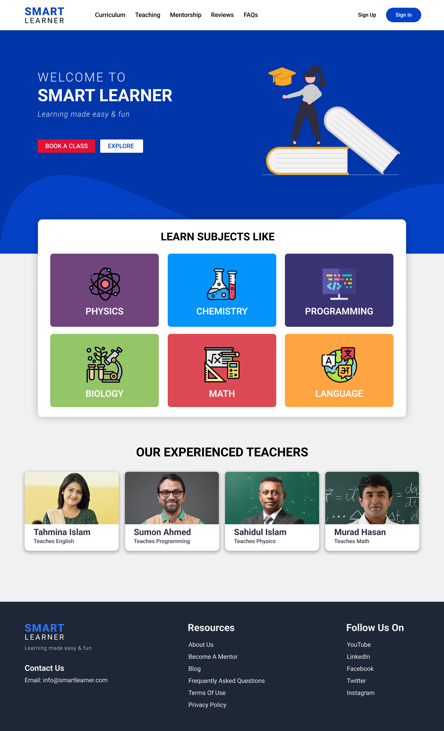

* + 1. **Login form**

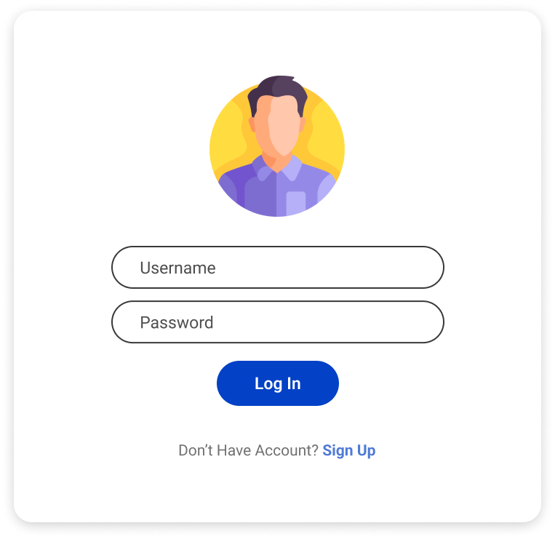

### **Student Functions:** students can select the function

* + 1. 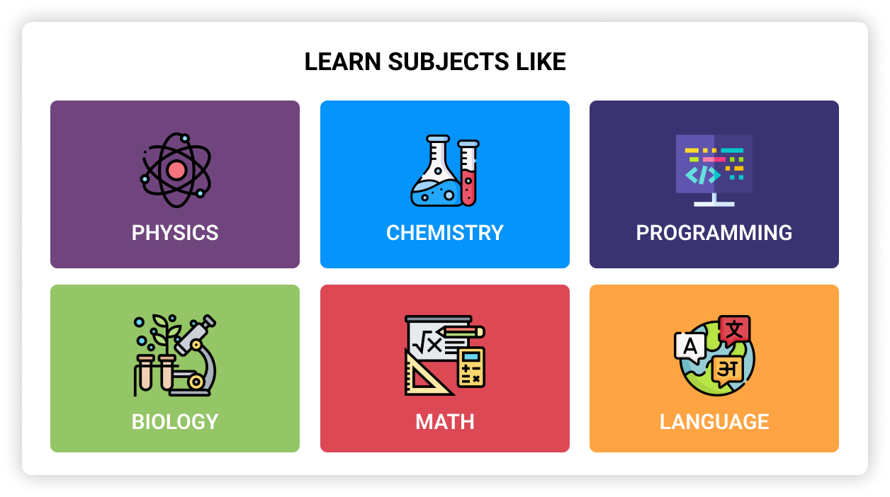**Student learn function**

### **Student retention function**

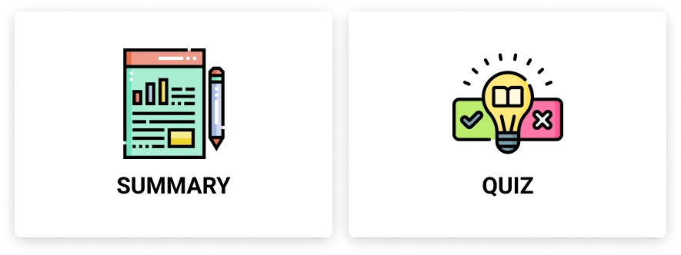

* + 1. **Student submits summery**

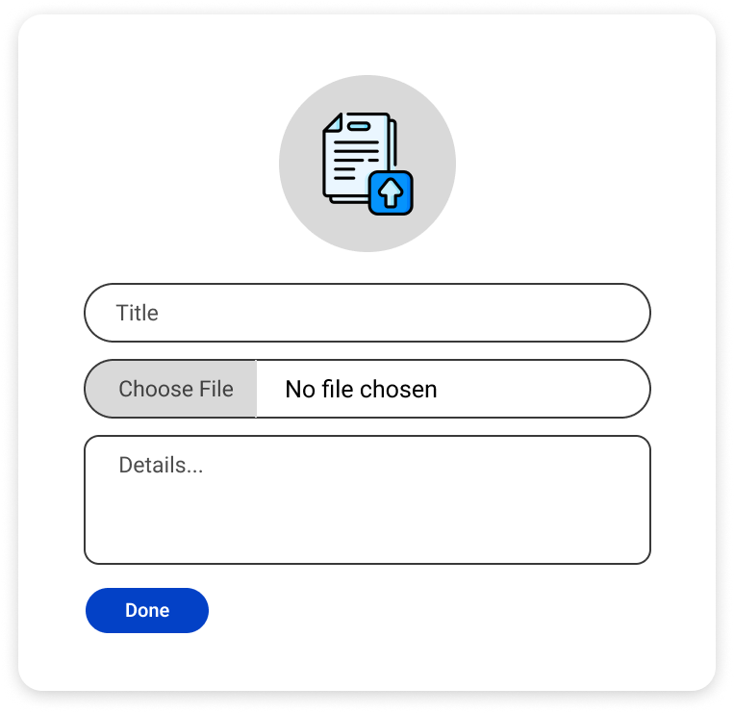

### **Creator Profile**

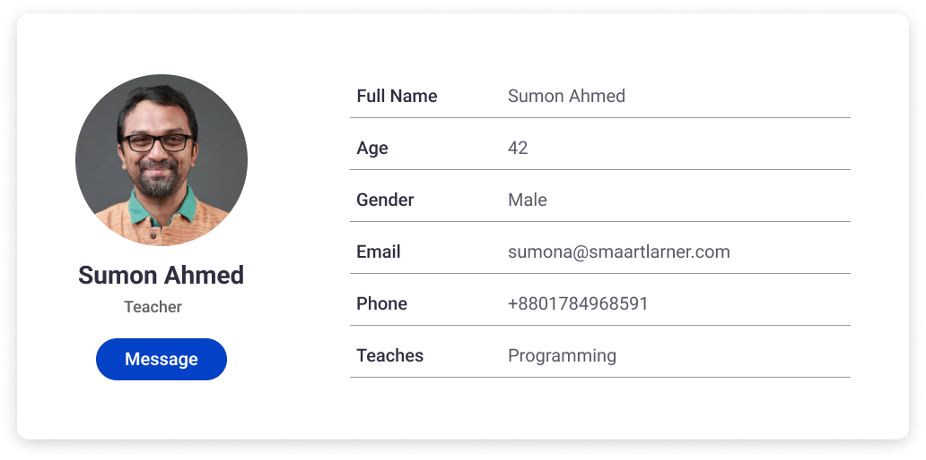

* + 1. 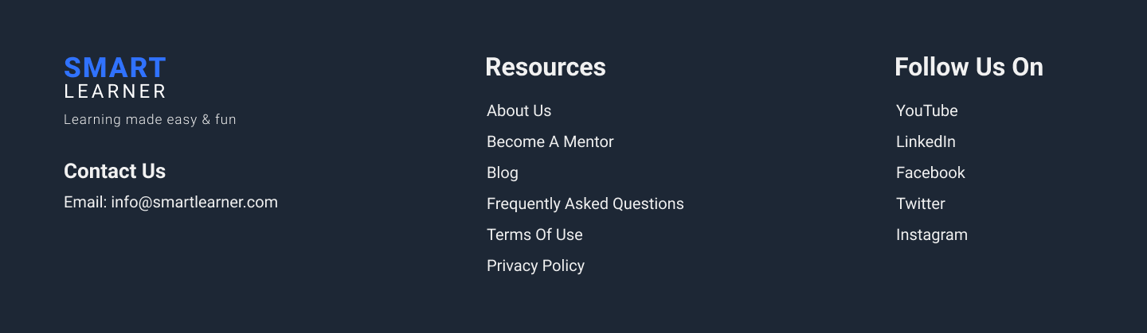**Footer**

## Other Requirements

A small team with strong application development abilities will work on this project.

Total budget: 300,000 BDT

The needed number of engineers are five, and the total development time is 15 weeks.

## FEATURES NOT TO BE TESTED

The following is a list of the areas that will not be specifically addressed. All testing in these areas will be indirect as a result of other testing efforts. For example:

* A student/creator can contact each other. In our Smart Learner application there is a feature where a student can contact with creator through messaging. This feature is not to be tested in this release of the software.
* Student can qualify themselves by taking online quizzes. This feature is yet to be tested.

## TESTING APPROACH

* Unit Testing
* Integration Testing
* System Testing
* Acceptance Testing
* Functional Testing

## Testing Levels

**SYSTEM/INTEGRATION** Testing is performed by the test manager and development team leader with assistance from the individual developers. Programs will enter into System/Integration test finally critical defects are corrected.

**UNIT TESTING** is done by the developer, then the results will be authorized by the team lead. Before unit testing is passed and accepted on to the test person, the programmer must submit proof of unit testing (test case list, sample output, data printouts, defect information). The test person will receive and validate all the test information.

**ACCEPTANCE** testing is done by the user or customer although other stakeholders may be involved as well, with the assistance of the test manager and development team leader. After the System/Integration test is completed, the acceptance test will run in parallel with the prevailing manual process for two weeks.

**Functional Testing:** Functional testing usually describes what the system does. Since functional testing is a type of black-box testing, the software's functionality can be tested without knowing the internal workings of the software. This means that testers do not need to know programming languages or how the software has been implemented.

## Test Tools

* Eclipse (For writing testing codes and execution)
* Selenium (Testing framework)
* Web Browser (Google Chrome, Mozilla Firefox)

## Meetings

The test team will meet once a week to evaluate success and identify issues and mistake as soon as possible. The project manager and the production team will meet with the research team leader once every two weeks. These two meetings will occur on different weeks. Additional sessions will be scheduled if necessary

## TEST CASES/TEST ITEMS

**Login Check**

|  |  |  |  |  |  |
| --- | --- | --- | --- | --- | --- |
| Project Name: Smart Learner | | | Test Designed by: Md. Ibrahim Shawon | | |
| Test Case ID: L_1 | | | Test Designed date: 18-04-2023 | | |
| Test Priority (Low, Medium, High): Medium | | | Test Executed by: Md. Ibrahim Shawon | | |
| Module Name: Login Session | | | Test Execution date: | | |
| Test Title: verify login with valid username and password | | |  | | |
| Description: Test website login page | | |  | | |
| Precondition (If any): User must have valid username and password | | | | | |
| Test Steps | Test Data | Expected Results | | Actual Results | Status (Pass/Fail) |
| 1. Go to the website 2. Enter username 3. Enter password 4. Click submit | Username: shawonc3  Password: 1234 | User should login into the application | | As expected, | Pass |
| Post Condition: User is validated with database and successfully login to account. The account session details are logged in the database. | | | | | |

**Sign Up Check:**

|  |  |  |  |  |  |
| --- | --- | --- | --- | --- | --- |
| Project Name: Smart Learner | | | Test Designed by: Md. Ibrahim Shawon | | |
| Test Case ID: FR_2 | | | Test Designed date:19-04-2023 | | |
| Test Priority (Low, Medium, High): Medium | | | Test Executed by: Md. Ibrahim Shawon | | |
| Module Name: Signup Session | | | Test Execution date: | | |
| Test Title: verify validation of required info | | |  | | |
| Description: Test website signup page | | |  | | |
| Precondition (If any): User must have valid username and password | | | | | |
| Test Steps | Test Data | Expected Results | | Actual Results | Status (Pass/Fail) |
| 1. Go to the website 2. Enter username 3. Enter email 4. Enter password 5. Enter age 6. Enter address 7. Click submit | Username: shawonc3  Email:shawonc3@gmail.com  Password: 1234  Age: 24 Address: Dhaka | User should signup into the application | | As expected, | Pass |
| Post Condition: User is validated with database and successfully created account. The account session details are logged in the database. | | | | | |

|  |  |  |  |  |  |
| --- | --- | --- | --- | --- | --- |
| Project Name: Smart Learner | | | Test Designed by: Kafi Anan Rafi | | |
| Test Case ID: L_3 | | | Test Designed date: 30-04-2023 | | |
| Test Priority (Low, Medium, High): Medium | | | Test Executed by: Kafi Anan Rafi | | |
| Module Name: Retention Session | | | Test Execution date: | | |
| Test Title: verify creating summary | | |  | | |
| Description: Test retention page | | |  | | |
| Precondition (If any): User must have input valid data | | | | | |
| Test Steps | Test Data | Expected Results | | Actual Results | Status (Pass/Fail) |
| Go to the website  Enter title  Enter detail  Click submit | Title: vector lesion summary  Detail: A vector is a quantity or phenomenon that has two independent properties: magnitude and direction. | New summary should be created | | As expected, | Pass |
| Post Condition: New summary is created successfully. | | | | | |

**Retention Center Section Check:**

**Creator Section Check**

|  |  |  |  |  |  |
| --- | --- | --- | --- | --- | --- |
| Project Name: Smart Learner | | | Test Designed by: Kafi Anan Rafi | | |
| Test Case ID: L_4 | | | Test Designed date: 30-04-2023 | | |
| Test Priority (Low, Medium, High): Medium | | | Test Executed by: Kafi Anan Rafi | | |
| Module Name: Creator Session | | | Test Execution date: | | |
| Test Title: verify valid creator content | | |  | | |
| Description: Test website creator page | | |  | | |
| Precondition (If any): Creator must be able to create new content | | | | | |
| Test Steps | Test Data | Expected Results | | Actual Results | Status (Pass/Fail) |
| 1. Go to the website 2. Enter title 3. Enter subject 4. Enter detail 5. Click submit | Title: Learn Vocabulary Subject: English  Detail: The One | New content should be created | | As expected, | Pass |
| Post Condition: New content is created successfully. | | | | | |

**Change Password**

|  |  |  |  |  |
| --- | --- | --- | --- | --- |
| Project Name: Smart Learner | | | Test Designed by: Tasneem Binte Ameen | |
| Test Case ID: FP_08 | | | Test Designed date: 25, april,2023 | |
| Test Priority (Low, Medium, High): Medium | | | Test Executed by Tasneem Binte Ameen | |
| Module Name: Change password | | | Test Execution date: | |
| Test Title: Test the changing password | | |  | |
| Description: Test the password is changing or not | | |  | |
| Precondition: Student have to logged into the system then went to system menu after that go to profile option | | |  | |
| Test Steps | Test Data | Expected Results | Actual Results | Status (Pass/Fail) |
| 1. Login to the website 2. Go to menu option 3. From menu, go to the profile option. 4. Click reset password 5. Enter new password 6. Click submit | Password: 12345 | Password should be added by the user and stored in database. | As expected, | Pass |
| Post Condition: Database should be updated password | | |  | |

## Update Profile

|  |  |  |  |  |
| --- | --- | --- | --- | --- |
| Project Name: Smart Learner | | | Test Designed by Tasneem Binte Ameen | |
| Test Case ID: FP_09 | | | Test Designed date: 21, April,2023 | |
| Test Priority (Low, Medium, High): Low | | | Test Executed by: Tasneem Binte Ameen | |
| Module Name: Update Profile | | | Test Execution date: | |
| Test Title: Test the update profile | | |  | |
| Description: Test the profile is update or not | | |  | |
| **Precondition:** User have logged in and went to system menu | | |  | |
| Test Steps | Test Data | Expected Results | Actual Results | Status (Pass/Fail) |
| 1. Login to the website  2. Go to menu option  3. Click profile option  4. Click update profile  5. Add updated information.  6. Click update | Email:[Tasnimameen12@gmail.com](mailto:Tasnimameen12@gmail.com)  First Name: Tasneem  Last Name: Ameen  Phone No: 01814351190 | User provide information email and phone number should be  verified and User edit their name and click save it will show that the  profile is update | As expected, | Pass |
| Post Condition: After changing their name email, phone number profile show is update | | |  |  |

# 8. **ITEM PASS/FAIL CRITERIA**

Six test cases in total were used to implement the Smart Learner. First off, 95% of the test cases passed when they were applied to the system during unit testing. But regrettably, 5% of attempts failed. Due to several database query-related problems, the test cases were failing. All test cases were successfully executed and passed the test when they were applied after solving query-related issues.

### **9.** **STAFFING AND TRAINING NEEDS**

The staffing and training needs for a student learning platform would depend on the specific goals and objectives of the platform, as well as the scope and complexity of the platform itself. Here are some potential staffing and training needs for a student learning platform:

**Admin:** The platform would likely need one or more administrators who are responsible for managing and maintaining the platform, including managing user accounts, monitoring system performance, and troubleshooting issues. These administrators would need to be trained on the platform's features and tools, as well as any relevant technical skills and protocols.

**Content developers:** The platform would likely need content developers who are responsible for creating and curating the learning materials, such as videos, readings, and assessments. These content developers would need to be knowledgeable in the subject matter they are developing materials for, and they would need to be trained on the platform's content management tools and processes.

**Support staff:** The platform would likely need customer support staff who are responsible for assisting users with any issues or questions they have about the platform. These staff would need to be trained on the platform's features and tools, as well as any relevant customer service skills and protocols.

**Instructional designers:** The platform could also benefit from instructional designers who are responsible for designing and implementing effective learning experiences on the platform. These instrumental designers would need to be knowledgeable in instructional design principles and techniques, and they would need to be trained on the platform's features and tools for creating and delivering learning content.

## 10.TESTING SCHEDULE

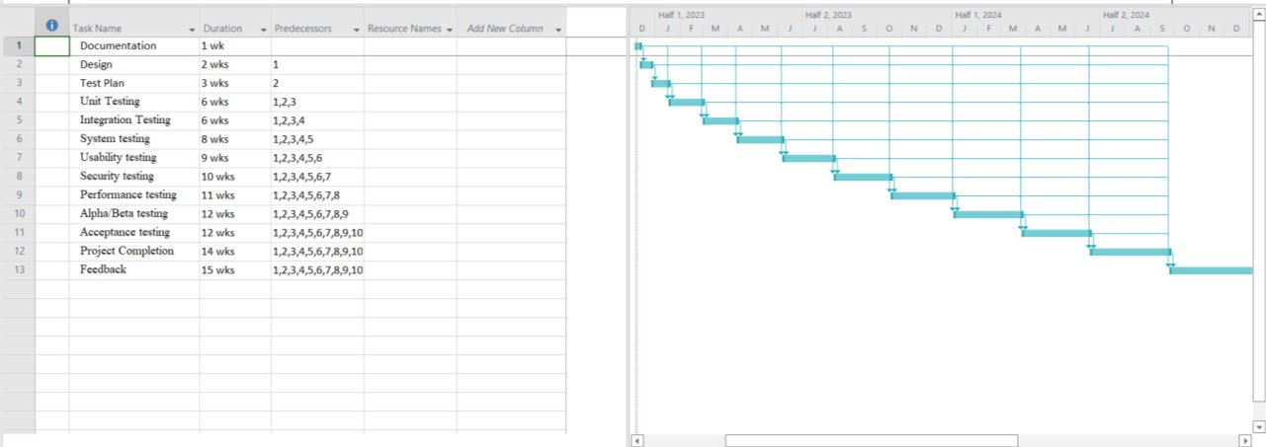

## 11. PLANNING RISKS AND CONTINGENCIES

**Power outage:** Creating a list of options for power supply that will deliver electricity on demand. Reach an agreement with clients and reschedule activities to make up for lost training hours.

**Network Failure:** There should be one primary and one backup broadband link. If any issues arise, we can switch to another network.

**Disaster and severe weather event:** In the case of a storm or adverse weather event, you have the right to cancel without penalty. Cancel the planning phase as soon as possible.

## APROVALS

|  |  |
| --- | --- |
| **Name** | **:** |
| **Designation** | **:** |
| **company** | **:** |
| **Signature** | **:** |